Use Case Name
AI-Powered Duplicate Bug Detection and Intelligent Bug Creation System
Use Case Description
This use case describes an AI-powered system that helps testers identify duplicate bugs before creating new defect reports in the bug tracking system.
Problem Statement
In large enterprise QA environments, multiple teams work on different modules of the same application. Each team may discover defects independently during testing. Because the bug database is large and distributed across many modules, testers often do not know whether a defect has already been reported by another team.
When a tester creates a new bug without knowing an identical bug already exists, the following process typically occurs:
- The tester logs a new bug in the system.
- A triage or trigger process notifies the Scrum Master or defect management team.
- The Scrum Master reviews the bug and determines which development team or POD is responsible.
- The issue is then assigned to the relevant developers.
- During investigation, the developer realizes that the same bug already exists in the system.
- The developer shares the existing bug ID and marks the new bug as a duplicate.
This process results in unnecessary manual effort and delays. On average, identifying that a bug is a duplicate can take 30 minutes to 1 hour, involving testers, Scrum Masters, and developers.
Additionally, in large organizations where multiple PODs work in parallel, testers may not know:
- Which POD owns the module where the issue occurs
- Whether another POD has already reported the same defect
- Which bug ID already represents the issue
Because of this lack of visibility, duplicate bugs are frequently created, increasing the workload for triage and development teams.

Why This Use Case
In our organization, the system is developed by more than 35 POD divisions working in parallel. Each POD typically includes:
- 1 Scrum Master
- 1 QA Engineer
- 2 Frontend Developers
- 3 Backend Developers
When a tester discovers a bug in a specific screen or workflow, it is often unclear:
- Which POD is responsible for that functionality
- Whether the issue has already been reported by another team
- Whether an existing bug already represents the same problem
Because of this, testers may unintentionally create duplicate bugs. This leads to:
- Additional triage meetings
- Developer time spent identifying duplicates
- Delays in assigning the correct bug
- Increased noise in the bug tracking system
An AI-powered Duplicate Bug Detection Agent solves this problem by allowing testers to check for similar bugs before creating a new bug.
When the tester enters the bug title or description, the system:
- Searches the bug database using AI-based semantic similarity.
- Displays a list of existing bugs that are similar.
- Provides a similarity score and confidence level.
- Allows the tester to review those bugs before submitting a new one.
If no strong duplicate exists, the system recommends creating a new bug. This ensures that:
- Duplicate bugs are minimized
- Testers gain visibility across all PODs
- Developers receive cleaner and more accurate defect reports

Expected Benefits
Implementing this AI-based duplicate bug detection system provides several benefits:
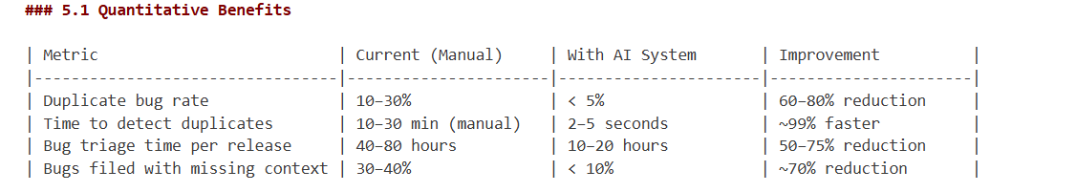
1. Reduced Duplicate Bugs
Testers can identify existing bugs before creating new ones, significantly reducing duplicate bug entries in the system.
2. Faster Defect Management
Instead of taking 30–60 minutes to identify duplicates, the system can detect similar bugs within 2–5 seconds.
3. Improved Cross-Team Visibility
Testers can see bugs reported by other PODs, even if they are working on different modules.
4. Reduced Developer Overhead
Developers spend less time identifying duplicate bugs and more time fixing actual issues.
5. Improved QA Productivity
Testers can quickly verify whether a defect already exists and focus on reporting new issues.
6. Cleaner Bug Database
The bug tracking system remains more organized, with fewer duplicate entries and better traceability.
7. Scalable for Large Teams
The system works efficiently even when multiple teams and hundreds of bugs are involved in each release cycle.

## 7. Success Criteria

| Criteria | Target |
|-----------------------------------------------------------------------|---------------------------------|
| Duplicate detection accuracy | ≥ 85% precision, ≥ 80% recall |
| End-to-end response time | ≤ 5 seconds |
| False positive rate (flagged but not duplicate) | < 10% |
| System availability | ≥ 99.5% uptime |
| Adoption by QA team | ≥ 80% of testers using within 1 month |

High-Level Architecture Diagram
